Records after duplicates removed
(n =330)
Abstract records screened
(n =329)
Records excluded
(n =292)
Full-text primary articles assessed for eligibility
(n =37)
Studies included in systematic review
(n = 5)

Records identified through database searching in English language
(n = 362)
Additional records identified through other sources
(n = 0 )

Full-text articles excluded,
(n = 32)
24 didn’t mention follow-up
1 author didn’t answer
7 studies had follow-up at less than 6 months

Figure 1. Flowchart of the review: RCTs on tinnitus management with rTMS

Figure 2. Forrest-plot showing the mean THI scores in rTMS versus Sham (1-4 weeks post-intervention) in the three studies
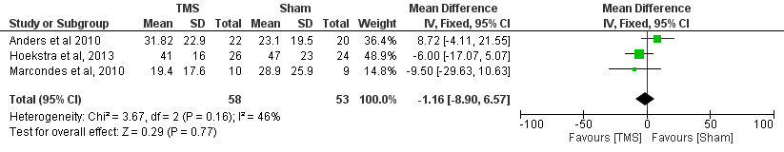

Figure 3. Forrest-plot showing the mean THI scores in rTMS versus Sham (6 months post-intervention) in the three studies

